**[ MUSA Council AGENDA ]**

Date: 07/26/24

Time: 9am

Location: Zoom

1. **Attendance**

| **Name** | **Position** | **Attendance** |
| --- | --- | --- |
| Emma Porter | President |  |
| Sayako Leznoff | Interim VP Finance |  |
| Jobert Leong | VP Admin |  |
| Denise Chung | VP Internal |  |
|  | VP External |  |
|  | AMS Representative |  |
|  | 4th Year Representative |  |
|  | 3rd Year Representative |  |
|  | 2nd Year Representative |  |
|  | 1st Year Representative |  |
|  | 4th Floor Lounge Manager |  |

1. **Call to Order**

The meeting was called to order at PDT

1. **Land Acknowledgement**

acknowledged that UBC’s Vancouver Point Grey campus is situated on the traditional, ancestral, unceded territory of the hən̓q̓əmin̓əm̓-speaking xʷməθkʷəy̓əm (Musqueam) people. The MUSA Council would also like to acknowledge that everyone is located in many places, near and far, and acknowledge the traditional owners and caretakers of those lands.

1. **Amendments to the Agenda**

1. **Adoption of the Agenda**

MOVED BY , SECONDED BY .

“BE IT RESOLVED THAT the agenda be adopted as .”

Result:

1. **Approval of Previous Meeting Minutes**

MOVED BY , SECONDED BY .

“BE IT RESOLVED THAT the meeting minutes of be adopted as _________.”

Result:

1. **Agenda Items**

* Introductions
  + We all know each other, but it would be nice to start out the meeting by connecting.
    - Where has been the coolest place you have traveled this summer? What are you looking forward to on MUSA this upcoming year?
* Presentation of the tentative Year Plan
* AMS Student Resource Fair
  + August 28th, 4pm-7pm, AMS Nest
* Imagine Day
  + September 3rd
    - SoM orientation
      * 9am, School of Music
    - Arts Faculty Fair
      * 11:30am-1:30pm, Buchanan Square
    - Pep Rally
      * 1:15pm, Thunderbird Arena
* FBF
  + September 6th, 9am-12pm, School of Music Lobby
    - <https://lettucemeet.com/l/8a3ON>
* Locker Boothing
  + September 4th-6th and 9th-13th, 9am-12pm, School of Music Lobby
    - <https://lettucemeet.com/l/Wb5D8>

1. **Action Items**
2. **Adjournment**

“BE IT RESOLVED THAT there being no further business the meeting be adjourned at PDT.”

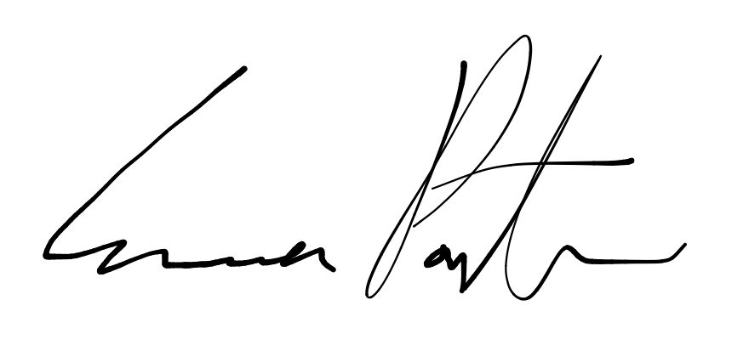

___________________________

**Emma Porter**

President

UBC Music Undergraduate Students’ Association

Respectfully submitted by

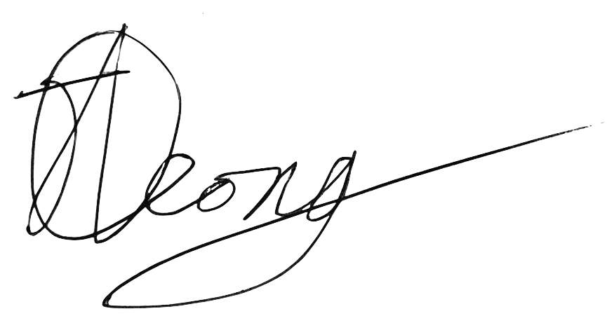

**Jobert Leong**

Vice President of Administration

UBC Music Undergraduate Students’ Association