**[ MUSA Council AGENDA ]**

Date: 03/03/25

Time: 6:00pm PST

Location: MUSA Office + Discord

1. **Attendance**

| **Name** | **Position** | **Attendance** |
| --- | --- | --- |
| Emma Porter | President | P |
| Sayako Leznoff | VP Finance | P |
| Jobert Leong | VP Admin | P |
| Denise Chung | VP Internal | P |
| Deanicka Loy Sales | VP External | P |
| Mayvelee Bugh | VP Student Resource | P |
| Maryam Khamis | 4th Year Representative | P |
| Matthew Lew | 3rd Year Representative | P |
| Jalen Logan | 2nd Year Representative | P |
| Zaiden Grayda-Reyes | 1st Year Representative | P |

1. **Call to Order**

The meeting was called to order at 6:10pm PDT

1. **Land Acknowledgement**

Emma acknowledged that UBC’s Vancouver Point Grey campus is situated on the traditional, ancestral, unceded territory of the hən̓q̓əmin̓əm̓-speaking xʷməθkʷəy̓əm (Musqueam) people. The MUSA Council would also like to acknowledge that everyone is located in many places, near and far, and acknowledge the traditional owners and caretakers of those lands.

1. **Amendments to the Agenda**

1. **Adoption of the Agenda**

MOVED BY JJ, SECONDED BY Matty.

“BE IT RESOLVED THAT the agenda be adopted as presented.”

Result: presented

1. **Approval of Previous Meeting Minutes**

MOVED BY Denise, SECONDED BY Zaiden.

“BE IT RESOLVED THAT the meeting minutes of 02/26/25 be adopted as approved.”

Result: approved

| **VII. Agenda Items** | **VIII. Action Items** |
| --- | --- |
| MHE - Flower Crowns | |
| * Recap?   + Class conflicts   + Reuse decorations in formal to save money |  |
| Movie Night | |
| * Recap?   + Low attendance     - Clashed with keyboard divisional, string studio recital, external event   + Better movie and date, bring plates for pizza next time |  |
| Social Media Posts | |
| * Event Recap Posts   + Exclude movie night * Tangled Reel   + Film date confirmed?   + Wednesday during SWE break * Orchestra bassoon promo vid | * **Jobert**, **Matty**, **JJ**, and **Zaiden** will film the jig reel Wednesday during SWE break (learn dance moves!) |
| Elections | |
| * Jeremy sent out email to students today, encourage students to run! * AMS Elections   + Endorsements   + **MUSA** has decided 8-2 to endorse Riley Huntley for AMS President |  |
| Formal | |
| * Officially regular ticket sales ($20)   + Posters to go up with bounce link (in QR code form) so students can find it easier * Decorations   + Thank you to Zaiden for organizing the google doc!   + If no one else has other opinions, I will place an amazon order   + Decoration making (if we have everything) will be Wed, Mar 5, at 6pm * Superlatives   + <https://forms.gle/G7E66VN9eUPkvaty9>   + QR codes | * **Jobert** will email sponsors for prizes (include Koerner’s) * **Maryam**, **Denise**, **JJ**, **Valentine** will help with making decorations on March 5th at 6pm * **Emma**, **Denise**, **Deanicka**, **JJ**, **Maryam**, **Saya**, **Mayvelee** will help to setup the formal at 5:30pm * **Saya**, **Dario**, **Denise**, **Zaiden**, **Deanicka**, **Matty**, **JJ**, **Jobert**, **Mayvelee** will help scrap the formal at 10-10:30pm |
| FBF | |
| * This friday * Assign to following   + **Emma**: Order coffee   + **Emma**, **Saya**: Pick up coffee and pastries   + **Jobert**: Set up table in lobby (grab things from office)   + **Mayvelee**, **JJ**: 9am-10am   + **Denise**: 10am-11am   + **Jobert**, **Denise**: 11am-12pm   + **Jobert**: Tear down and clean * Do we have all the supplies we need? | * **Emma**: Order coffee * **Emma**, **Saya**: Pick up coffee and pastries * **Jobert**: Set up table in lobby (grab things from office) * **Mayvelee**, **JJ**: 9am-10am * **Denise**: 10am-11am * **Jobert**, **Denise**: 11am-12pm * **Jobert**: Tear down and clean |
| Koerner’s Night | |
| * This thursday, 7pm-11pm * Make sure to post on social media and invite all your friends * Attendance?   + **Emma**, **Zaiden**, **Jobert**, **Denise** | * **Emma**, **Zaiden**, **Jobert**, **Denise** will be there |
| Council Photos | |
| * Saturday, March 8th, 10am, Evangelos |  |

**IX. Adjournment**

“BE IT RESOLVED THAT there being no further business the meeting be adjourned at 7:15pm.”

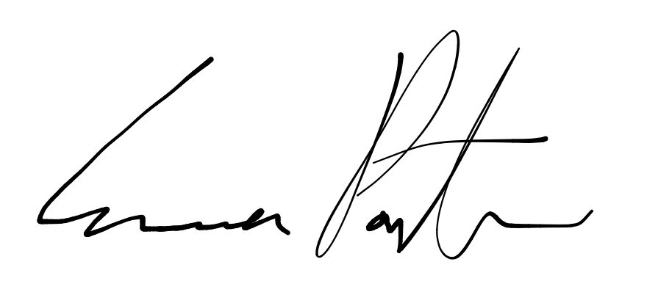

___________________________

**Emma Porter**

President

UBC Music Undergraduate Students’ Association

Respectfully submitted by

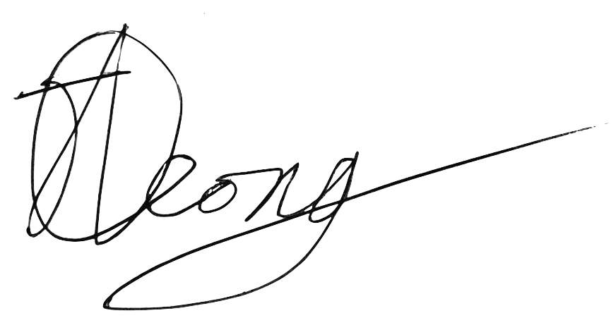

**Jobert Leong**

Vice President of Administration

UBC Music Undergraduate Students’ Association