**[ MUSA Council AGENDA ]**

Date: 03/03/25

Time: 6:00pm PST

Location: MUSA Office + Discord

1. **Attendance**

| **Name** | **Position** | **Attendance** |
| --- | --- | --- |
| Emma Porter | President |  |
| Sayako Leznoff | VP Finance |  |
| Jobert Leong | VP Admin |  |
| Denise Chung | VP Internal |  |
| Deanicka Loy Sales | VP External |  |
| Mayvelee Bugh | VP Student Resource |  |
| Maryam Khamis | 4th Year Representative |  |
| Matthew Lew | 3rd Year Representative |  |
| Jalen Logan | 2nd Year Representative |  |
| Zaiden Grayda-Reyes | 1st Year Representative |  |

1. **Call to Order**

The meeting was called to order at ______ PDT

1. **Land Acknowledgement**

acknowledged that UBC’s Vancouver Point Grey campus is situated on the traditional, ancestral, unceded territory of the hən̓q̓əmin̓əm̓-speaking xʷməθkʷəy̓əm (Musqueam) people. The MUSA Council would also like to acknowledge that everyone is located in many places, near and far, and acknowledge the traditional owners and caretakers of those lands.

1. **Amendments to the Agenda**

1. **Adoption of the Agenda**

MOVED BY , SECONDED BY .

“BE IT RESOLVED THAT the agenda be adopted as .”

Result:

1. **Approval of Previous Meeting Minutes**

MOVED BY , SECONDED BY .

“BE IT RESOLVED THAT the meeting minutes of be adopted as _________.”

Result:

| **VII. Agenda Items** | **VIII. Action Items** |
| --- | --- |
| MHE - Flower Crowns | |
| * Recap? |  |
| Movie Night | |
| * Recap? |  |
| Social Media Posts | |
| * Event Recap Posts * Tangled Reel   + Film date confirmed? * Orchestra bassoon promo vid |  |
| Elections | |
| * Jeremy sent out email to students today, encourage students to run! * AMS Elections   + Endorsements |  |
| Formal | |
| * Officially regular ticket sales ($20)   + Posters to go up with bounce link so students can find it easier * Decorations   + Thank you to Zaiden for organizing the google doc!   + If no one else has other opinions, I will place an amazon order   + Decoration making (if we have everything) will be Wed, Mar 5, at 6pm * Superlatives   + https://forms.gle/G7E66VN9eUPkvaty9 |  |
| FBF | |
| * This friday * Assign to following   + Order coffee   + Pick up coffee and pastries   + Set up table in lobby (grab things from office)   + 9am-10am   + 10am-11am   + 11am-12pm   + Tear down and clean * Do we have all the supplies we need? |  |
| Koerner’s Night | |
| * This thursday, 7pm-11pm * Make sure to post on social media and invite all your friends * Attendance? |  |
| Council Photos | |
| * Saturday, March 8th, 10am, Evangelos |  |

**IX. Adjournment**

“BE IT RESOLVED THAT there being no further business the meeting be adjourned at .”

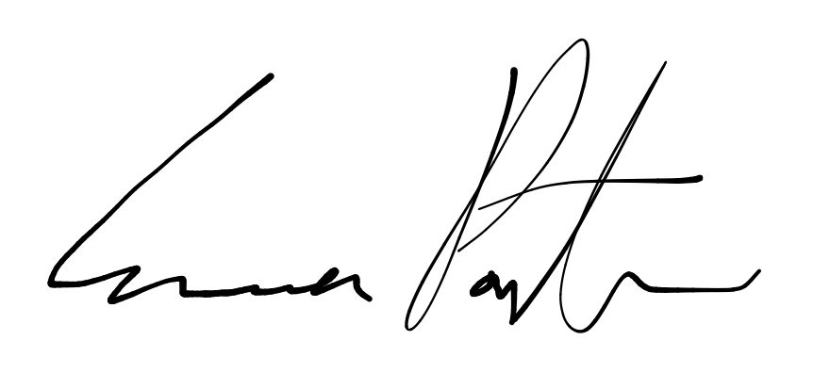

___________________________

**Emma Porter**

President

UBC Music Undergraduate Students’ Association

Respectfully submitted by

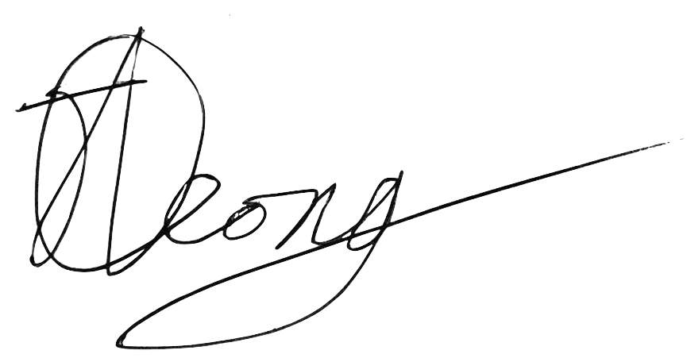

**Jobert Leong**

Vice President of Administration

UBC Music Undergraduate Students’ Association