**[ MUSA Council AGENDA ]**

Date: 10/30/24

Time: 8:00am

Location: MUSA Office

1. **Attendance**

| **Name** | **Position** | **Attendance** |
| --- | --- | --- |
| Emma Porter | President |  |
| Sayako Leznoff | VP Finance |  |
| Jobert Leong | VP Admin |  |
| Denise Chung | VP Internal |  |
| Deanicka Loy Sales | VP External |  |
| Mayvelee Bugh | VP Student Resource |  |
| Maryam Khamis | 4th Year Representative |  |
| Matthew Lew | 3rd Year Representative |  |
| Jalen Logan | 2nd Year Representative |  |
| Zaiden Grayda-Reyes | 1st Year Representative |  |

1. **Call to Order**

The meeting was called to order at PDT

1. **Land Acknowledgement**

acknowledged that UBC’s Vancouver Point Grey campus is situated on the traditional, ancestral, unceded territory of the hən̓q̓əmin̓əm̓-speaking xʷməθkʷəy̓əm (Musqueam) people. The MUSA Council would also like to acknowledge that everyone is located in many places, near and far, and acknowledge the traditional owners and caretakers of those lands.

1. **Amendments to the Agenda**

1. **Adoption of the Agenda**

MOVED BY , SECONDED BY .

“BE IT RESOLVED THAT the agenda be adopted as ________.”

Result:

1. **Approval of Previous Meeting Minutes**

MOVED BY , SECONDED BY .

“BE IT RESOLVED THAT the meeting minutes of be adopted as _________.”

Result:

| **VII. Agenda Items** | **VIII. Action Items** |
| --- | --- |
| Pumpkin Carving | |
| * General thoughts? * Insta recap post to go up this week |  |
| Halloween | |
| * Meet outside SoM at 9am * Instagram reels/tiktok ideas to make * Does anyone still need help with their costume? |  |
| Faculty Trick-or-Treating | |
| * Emma will decorate the doors tonight of the faculty * Candy was ordered to give to profs yesterday |  |
| Free Breakfast Friday | |
| * November 1st, 9am-12pm, SoM lobby   + 8:30am pick up at Tims: Saya and Denise   + 8:30am lobby set up: Jobert   + 9am-10am: Denise and Mayvelee   + 10am-11am: Matty and Zaiden   + 11am-12pm: Emma and Maryam * Denise post a story of the food to remind students |  |
| Rabbitats | |
| * Friday, November 1st, 3pm-5pm, SoM Lobby * Everyone will be there * Make sure to take plenty of photos for instagram!   + Invite all your friends |  |

**IX. Adjournment**

“BE IT RESOLVED THAT there being no further business the meeting be adjourned at .”

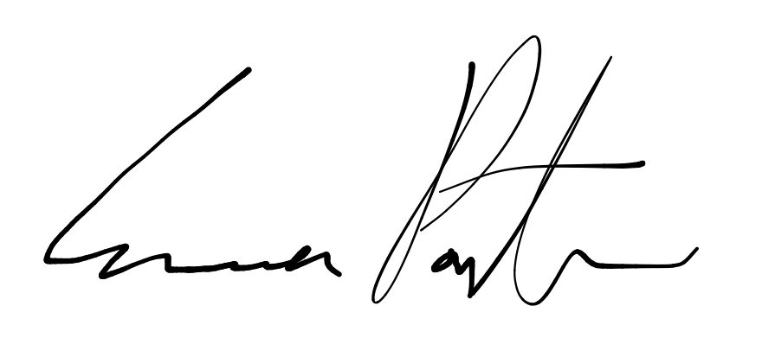

___________________________

**Emma Porter**

President

UBC Music Undergraduate Students’ Association

Respectfully submitted by

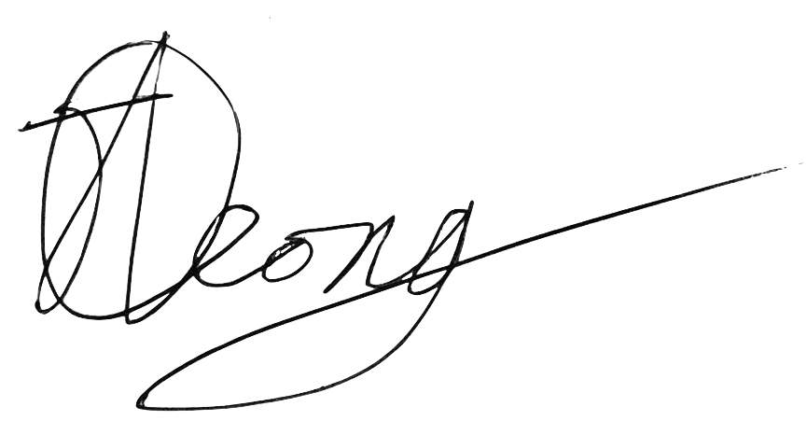

**Jobert Leong**

Vice President of Administration

UBC Music Undergraduate Students’ Association