**[ MUSA Council AGENDA ]**

Date: 01/09/25

Time: 2pm

Location: MUSA Office

1. **Attendance**

| **Name** | **Position** | **Attendance** |
| --- | --- | --- |
| Emma Porter | President |  |
| Sayako Leznoff | VP Finance |  |
| Jobert Leong | VP Admin |  |
| Denise Chung | VP Internal | E |
| Deanicka Loy Sales | VP External |  |
| Mayvelee Bugh | VP Student Resource |  |
| Maryam Khamis | 4th Year Representative |  |
| Matthew Lew | 3rd Year Representative |  |
| Jalen Logan | 2nd Year Representative |  |
| Zaiden Grayda-Reyes | 1st Year Representative |  |

1. **Call to Order**

The meeting was called to order at ______ PDT

1. **Land Acknowledgement**

acknowledged that UBC’s Vancouver Point Grey campus is situated on the traditional, ancestral, unceded territory of the hən̓q̓əmin̓əm̓-speaking xʷməθkʷəy̓əm (Musqueam) people. The MUSA Council would also like to acknowledge that everyone is located in many places, near and far, and acknowledge the traditional owners and caretakers of those lands.

1. **Amendments to the Agenda**

1. **Adoption of the Agenda**

MOVED BY , SECONDED BY .

“BE IT RESOLVED THAT the agenda be adopted as .”

Result:

1. **Approval of Previous Meeting Minutes**

MOVED BY , SECONDED BY .

“BE IT RESOLVED THAT the meeting minutes of be adopted as _________.”

Result:

| **VII. Agenda Items** | **VIII. Action Items** |
| --- | --- |
| FBF | |
| * Friday, January 10th, 9am-12pm * 2 take away coffee carafes, 4 dozen donuts   + Tim Hortons   + Will need to be pre-ordered and picked up at 8:30am * Inventory Check   + Stir sticks, cups, lids, tea, tablecloth, napkins, extension cord, water heater, hot chocolate     - Option to buy takeaway hot chocolate & french vanilla from Tims as well * Sign-up for table times   + When2meet sent in slack   + https://www.when2meet.com/?28166566-evE6e   + 8:30am - 2 people pick up order from Tims   - 1 person set up table in the lobby  - 9am-10am  - 10am-11am  - 11am-12pm | * Saya and Mayvelee pick up * Jobert table set up * Mayvelee * Dean and Zaiden * Jobert |
| Retreat | |
| * Pushed our retreat dinner into the new year * When2meet sent in slack   + https://www.when2meet.com/?28166540-ANKRz * If we choose just the one retreat instead of two (usually one per semester), can the budget possibly be increased? |  |
| Social Media | |
| * Maryam’s turn for instagram takeover! * Any reels people want to make ? |  |
| Candy Grams | |
| * Origami hearts, candy bags   + $2 heart, $3 candy bag * Boothing the 2 weeks leading up to Valentine’s Day (Feb 3-7, 10-13) 9am-2pm   + When2meet sent in slack   + <https://www.when2meet.com/?28166692-64Yub> |  |
| Merch | |
| * Waiting on the link for UBC School of Music hoodies to drop from the bookstore |  |
| Formal | |
| * Venue   + Great Hall North has been booked for February 28th from 4pm-12am   + Everyone who is able, will meet at the hall for 4pm to set up food and decorations and get ready for the event * Food   + Food platters and snacks from the grocery store will be picked up day of * Alcohol   + To ensure we can have alcohol but underage students can still attend, we will need to hire a bartender     - AMS bartender or do we want to find an outside source? * Decorations   + <https://pin.it/4LV02pvBL>   + We should create a decoration committee of 4-5 people to help decide what to use and what we can make vs need to buy     - Committee will present ideas at meeting on Jan 23rd * Photo Booth   + Do we hire the same company as last year or just hire a roaming photographer and no booth? * Tickets   + $10 early bird, $15 regular, $20 at the door   + Selling Ticket options     - Lobby boothing the 3 weeks leading up to the event (Feb 10-14, Feb 24-27)       * There’s a middle week of reading break so we won't be able to booth the whole time     - Bounce App       * An event app used by the AMS and other constituencies to sell tickets for events, have upload photo and comments option       * Tickets do have a small fee (either students pay $10 and we receive $8.41 of that, or they pay $11.59 and we receive $10)       * Benefit is that we don't have to booth and students would have a downloadable ticket * Music   + Hire a DJ again |  |
| Mental Health Event | |
| * Lunar New Year |  |
| Lounge Decoration | |
| * Decorations from christmas need to be taken back to the office * Making sure we are putting our posters up in the lounge for all our events |  |
| Director Search | |
| - |  |
| Pub Night | |
| * Koerner’s, the Gallery, the Pit   + We will have to make this explicitly a 19+ event to ensure no one gets in trouble |  |

**IX. Adjournment**

“BE IT RESOLVED THAT there being no further business the meeting be adjourned at .”

**

___________________________

**Emma Porter**

President

UBC Music Undergraduate Students’ Association

Respectfully submitted by

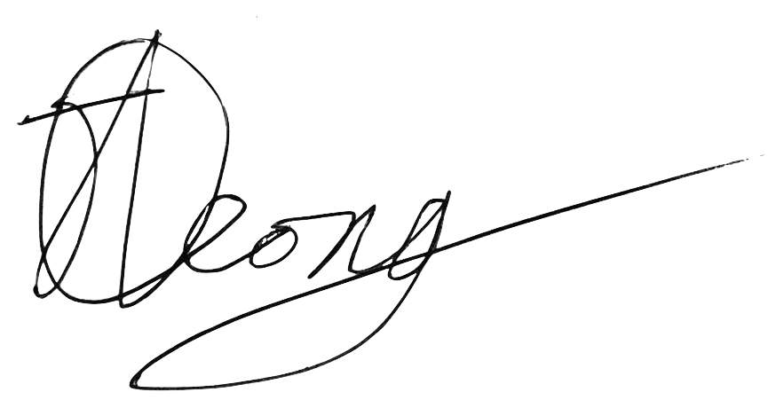

**Jobert Leong**

Vice President of Administration

UBC Music Undergraduate Students’ Association