**[ MUSA Council AGENDA ]**

Date: 01/21/25

Time: 7:30pm

Location: MUSA Office

1. **Attendance**

| **Name** | **Position** | **Attendance** |
| --- | --- | --- |
| Emma Porter | President | P |
| Sayako Leznoff | VP Finance | P |
| Jobert Leong | VP Admin | P |
| Denise Chung | VP Internal | P |
| Deanicka Loy Sales | VP External | P |
| Mayvelee Bugh | VP Student Resource | P |
| Maryam Khamis | 4th Year Representative | P |
| Matthew Lew | 3rd Year Representative | P |
| Jalen Logan | 2nd Year Representative | P |
| Zaiden Grayda-Reyes | 1st Year Representative | P |

1. **Call to Order**

The meeting was called to order at 7:32pm PDT

1. **Land Acknowledgement**

Emma acknowledged that UBC’s Vancouver Point Grey campus is situated on the traditional, ancestral, unceded territory of the hən̓q̓əmin̓əm̓-speaking xʷməθkʷəy̓əm (Musqueam) people. The MUSA Council would also like to acknowledge that everyone is located in many places, near and far, and acknowledge the traditional owners and caretakers of those lands.

1. **Amendments to the Agenda**

Jobert: AUS Purple cards

1. **Adoption of the Agenda**

MOVED BY JJ, SECONDED BY Matty.

“BE IT RESOLVED THAT the agenda be adopted as amended.”

Result: amended

1. **Approval of Previous Meeting Minutes**

MOVED BY Mayvelee, SECONDED BY Deanicka.

“BE IT RESOLVED THAT the meeting minutes of 01/14/25 be adopted as presented.”

Result: presented

| **VII. Agenda Items** | **VIII. Action Items** |
| --- | --- |
| AUS Purple Card | |
| * **Jobert**: Could we join * **JJ**: MUSA-specific version possible * **Jobert**: We’re the smallest constituency, not as viable, especially with musician-specific discounts (e.g. Long and McQuade, Tom Lee) * **Emma**: Tom Lee and Long and McQuade already have student discounts (show your student ID) | * **Jobert** will ask AUS if MUSA can be a part of the Purple Card scheme |
| Interfaculty Cup | |
| * February 7th, 15 min time slots * Volunteers needed! * Archery Tag (1pm-3:30pm), Oversized Volleyball (5pm-6:30pm), Wheelchair Basketball (7:30pm-9pm) * SIgn up link has been sent on slack and posted on the musa instagram   + Be sure to share with students and encourage people to join * Does musa want to have a team for any of the events?   + Ideal to have at least one team for each event | * **Zaiden**, **Mayvelee**, **JJ**, **Emma**, **Denise**, **and Matty** will be a volleyball team |
| MUSA Council Photo | |
| * Photos will be March 8th, 10am, 3156 W Broadway * Please be on time! * Dress code/colour scheme?   + Blue, black, and white   + References to past years are in the drive for inspo | * Blue, black, and white colour scheme for photo (no jeans!) |
| MHE | |
| * Thursday, January 23rd, 12pm-3pm, Room 338 SoM * Who can be there to help set up and tear down?   + Set up: **Jobert**, **Mayvelee**, **JJ**   + Tear down: **Emma**, **Zaiden**, **Matty**   + Will need to grab a few foldable tables from the music office     - Also good to have tablecloths from the musa office | * Set up: **Jobert**, **Mayvelee**, **JJ** * Tear down: **Emma**, **Zaiden**, **Matty** |
| Formal | |
| * Venue   + Cecil Green Park House * Catering Budget   + Sage Catering, ~$2000 (light refreshments) |  |
| Koerners Event | |
| * Students are hoping for another Koerner’s Night   + February 6th, 7-11pm (19+) * Date the works for all of us? | * February 6th, 7-11pm (19+) * Everyone will be there except **Emma** |
| GRETA Night | |
| * Greta Arcade bar in gastown has reached out offering no cover and extra discounts if we host an event on a Friday or Saturday night   + Students will need to show student ID at the door * Would we be interested in hosting an event there?   + Could entice students with some drink tickets | * **Mayvelee** will share discount info (no cover charge) |
| Elections | |
| * Time to pick an election timeline so that we can post and give students (and yourselves) time to decide if they want to run!   + March election period * AGM date and time based on election |  |
| Windfest | |
| * Saturday, January 25th, 9am-2pm * Schedule for the table boothing has been sent in discord * Single/double-reed/flute tip jars * What drinks and snacks will we buy? Who will pick it up? * Granola bars, juice boxes, water bottles | * **Jobert** will buy granola bars, juice boxes, water bottles from Costco ($100 budget) |
| Just Desserts Award | |
| * MUSA needs to nominate a student or faculty that has gone above and beyond this year for the school of music and the students. This is an award to celebrate and honor someone we appreciate   + There is a google form for anonymous recommendations, we will weed it down from there by secret vote   + https://forms.gle/YFkzsnbWfhuuSgjC7 |  |

**IX. Adjournment**

“BE IT RESOLVED THAT there being no further business the meeting be adjourned at 8:41pm.”

**

___________________________

**Emma Porter**

President

UBC Music Undergraduate Students’ Association

Respectfully submitted by

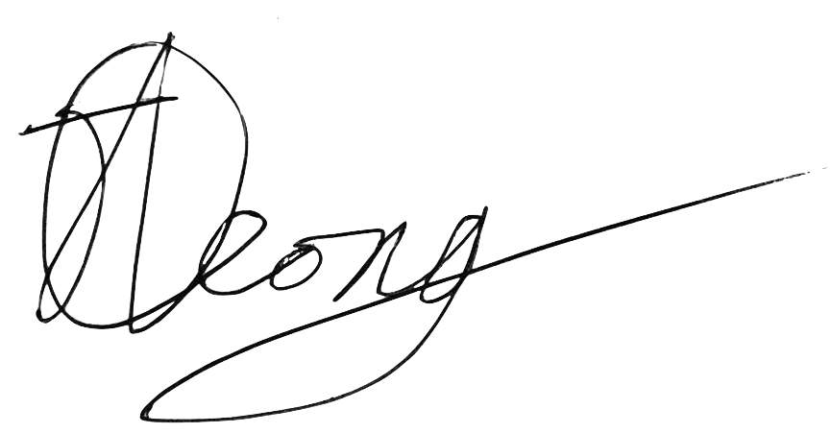

**Jobert Leong**

Vice President of Administration

UBC Music Undergraduate Students’ Association