**[ MUSA Council AGENDA ]**

Date: 03/17/25

Time: 7:00pm PST

Location: MUSA Office

1. **Attendance**

| **Name** | **Position** | **Attendance** |
| --- | --- | --- |
| Emma Porter | President | P |
| Sayako Leznoff | VP Finance | P |
| Jobert Leong | VP Admin | P |
| Denise Chung | VP Internal | P |
| Deanicka Loy Sales | VP External | P |
| Mayvelee Bugh | VP Student Resource |  |
| Maryam Khamis | 4th Year Representative | P |
| Matthew Lew | 3rd Year Representative |  |
| Jalen Logan | 2nd Year Representative |  |
| Zaiden Grayda-Reyes | 1st Year Representative | P |

1. **Call to Order**

The meeting was called to order at _______ PDT

1. **Land Acknowledgement**

_______ acknowledged that UBC’s Vancouver Point Grey campus is situated on the traditional, ancestral, unceded territory of the hən̓q̓əmin̓əm̓-speaking xʷməθkʷəy̓əm (Musqueam) people. The MUSA Council would also like to acknowledge that everyone is located in many places, near and far, and acknowledge the traditional owners and caretakers of those lands.

1. **Amendments to the Agenda**

1. **Adoption of the Agenda**

MOVED BY _______, SECONDED BY JJ.

“BE IT RESOLVED THAT the agenda be adopted as ________.”

Result:

1. **Approval of Previous Meeting Minutes**

MOVED BY ________, SECONDED BY ________.

“BE IT RESOLVED THAT the meeting minutes of _________ be adopted as _________.”

Result:

| **VII. Agenda Items** | **VIII. Action Items** |
| --- | --- |
| Formal Recap | |
| * Photo gallery will be emailed to students once we receive the digital gallery from Vancity Photo Booth * Any feedback received from other students? * Denise’s jars |  |
| AMS Awards Gala | |
| * Tuesday, March 18th, 5:30pm doors open, Convention Center * Who is attending? * Do we want to go together or separately? |  |
| Election | |
| * Candidates   + President: Sayako Leznoff, Jobert Leong   + VP Admin: Rue Beer   + VP Internal: Zaiden Grayda-Reyes   + VP External: Deanicka Loy Sales   + VP Finance: Lucy Moon   + VP Student Resource: Mayvelee Bugh * AGM   + Thursday, March 20th, 2-3pm, Room 338   + If any candidates cannot make it, they may submit a video   + Attendance? |  |
| Music Jeopardy | |
| * Thursday, March 20th, 7:30pm, Room TBD * Attendance? * Emma is almost done writing the questions * Please reshare insta post and make sure to invite all your friends!!   + Teams of 4, musa member can and should participate * Snacks?   + Who will pick up? |  |
| Lounge Puzzles | |
| * Purchase frames |  |

**IX. Adjournment**

“BE IT RESOLVED THAT there being no further business the meeting be adjourned at ________.”

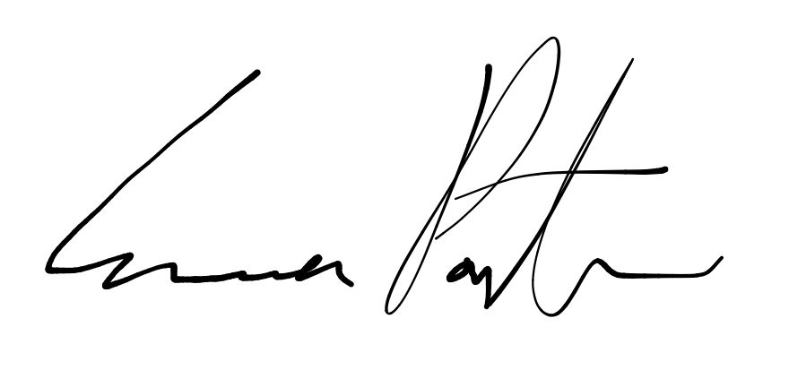

___________________________

**Emma Porter**

President

UBC Music Undergraduate Students’ Association

Respectfully submitted by

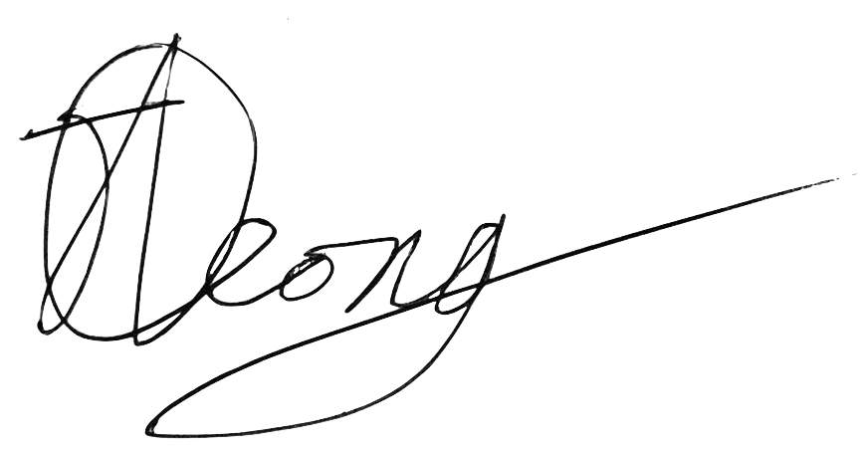

**Jobert Leong**

Vice President of Administration

UBC Music Undergraduate Students’ Association