**[ MUSA Council AGENDA ]**

Date: 01/28/25

Time: 7:00pm

Location: UBC School of Music + Discord

1. **Attendance**

| **Name** | **Position** | **Attendance** |
| --- | --- | --- |
| Emma Porter | President | P |
| Sayako Leznoff | VP Finance | P |
| Jobert Leong | VP Admin | P |
| Denise Chung | VP Internal | P |
| Deanicka Loy Sales | VP External | P |
| Mayvelee Bugh | VP Student Resource | L |
| Maryam Khamis | 4th Year Representative | P |
| Matthew Lew | 3rd Year Representative | P |
| Jalen Logan | 2nd Year Representative | P |
| Zaiden Grayda-Reyes | 1st Year Representative | P |

1. **Call to Order**

The meeting was called to order at ______ PDT

1. **Land Acknowledgement**

acknowledged that UBC’s Vancouver Point Grey campus is situated on the traditional, ancestral, unceded territory of the hən̓q̓əmin̓əm̓-speaking xʷməθkʷəy̓əm (Musqueam) people. The MUSA Council would also like to acknowledge that everyone is located in many places, near and far, and acknowledge the traditional owners and caretakers of those lands.

1. **Amendments to the Agenda**

1. **Adoption of the Agenda**

MOVED BY , SECONDED BY .

“BE IT RESOLVED THAT the agenda be adopted as .”

Result:

1. **Approval of Previous Meeting Minutes**

MOVED BY , SECONDED BY .

“BE IT RESOLVED THAT the meeting minutes of be adopted as _________.”

Result:

| **VII. Agenda Items** | **VIII. Action Items** |
| --- | --- |
| Class Piano Room Decoration | |
| * Zaiden reached out to Dr Aung about what type of decorating she is hoping for * Updates? |  |
| Formal | |
| * Catering? |  |
| NASA | |
| * Extra volunteer opportunities |  |
| Candy Grams | |
| * Boothing adjustments   + Some people need to switch their booth times * How to collect info for the candy grams   + Google sheet in the drive, same as last year |  |
| MHE Supplies | |
| * What do we need for all the upcoming events? * Who will go purchase everything? |  |
| FBF | |
| * Who will buy and pick up? * Boothing times |  |

**IX. Adjournment**

“BE IT RESOLVED THAT there being no further business the meeting be adjourned at .”

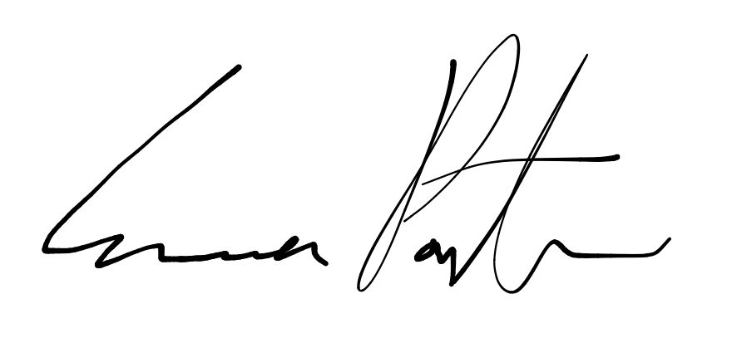

___________________________

**Emma Porter**

President

UBC Music Undergraduate Students’ Association

Respectfully submitted by

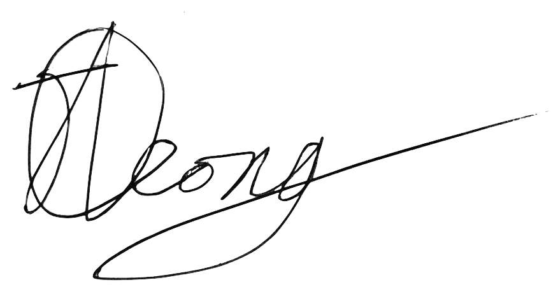

**Jobert Leong**

Vice President of Administration

UBC Music Undergraduate Students’ Association