**[ MUSA Council AGENDA ]**

Date: 11/20/24

Time: 8:00am

Location: MUSA Office

1. **Attendance**

| **Name** | **Position** | **Attendance** |
| --- | --- | --- |
| Emma Porter | President |  |
| Sayako Leznoff | VP Finance |  |
| Jobert Leong | VP Admin |  |
| Denise Chung | VP Internal |  |
| Deanicka Loy Sales | VP External |  |
| Mayvelee Bugh | VP Student Resource |  |
| Maryam Khamis | 4th Year Representative |  |
| Matthew Lew | 3rd Year Representative |  |
| Jalen Logan | 2nd Year Representative |  |
| Zaiden Grayda-Reyes | 1st Year Representative |  |

1. **Call to Order**

The meeting was called to order at PDT

1. **Land Acknowledgement**

acknowledged that UBC’s Vancouver Point Grey campus is situated on the traditional, ancestral, unceded territory of the hən̓q̓əmin̓əm̓-speaking xʷməθkʷəy̓əm (Musqueam) people. The MUSA Council would also like to acknowledge that everyone is located in many places, near and far, and acknowledge the traditional owners and caretakers of those lands.

1. **Amendments to the Agenda**

1. **Adoption of the Agenda**

MOVED BY , SECONDED BY .

“BE IT RESOLVED THAT the agenda be adopted as .”

Result:

1. **Approval of Previous Meeting Minutes**

MOVED BY , SECONDED BY .

“BE IT RESOLVED THAT the meeting minutes of be adopted as _________.”

Result:

| **VII. Agenda Items** | **VIII. Action Items** |
| --- | --- |
| Colouring Event | |
| * Tomorrow, 12pm-3pm, Room 462 * Today is the last day to put colouring pages into the drive   + Emma will be printing tomorrow morning * Snacks and pencil crayon purchase update? * Please make sure to spread the word   + Post to social media   + Year reps, make sure to send to the other students in your year |  |
| Mental Health Initiative - Prof. Raftery | |
| * Prof Rafftery is hosting an mental health event in Barnett with refreshments * He has asked musa to make a poster and help him spread the word |  |
| First Year Interfaculty Event | |
|  |  |
| Retreat | |
| * The day/time that the most of us are free is Monday, Nov 25, 9pm * <https://www.ams.ubc.ca/wp-content/uploads/2024/08/Gal-MenuFinalV3-August-2024.pdf> * <https://www.koerners.ca/menu> * <https://crafthouse.xdineapp.com/consumer#viewMenu/4675/UBC/617993/DINE%20IN%20MENU> |  |
| Social Media | |
| * Zaiden takes over instagram tomorrow!   + Will need to get the password from Denise * Thank you to Deanicka for all your help with the website! It looks great * There are a couple of reels in the drive to promo events and concerts   + Should we film some reels today to invite people to the colouring event |  |
| Merch | |
| * Emma has the designs from Carlo * If musa approves of the designs, we will get final quote and photos of the merch from the company * We will create a presale tab on the musa site, money will go directly to our bank account, and set a date for sales to be done. We will place the order with the company on what people want and have them ready when we come back from break |  |
| Formal | |
| * Throw themes out and Emma will create a poll in the insta chat * Post to go out this week   + No date or venue, but a “keep a look out/theme announcement”     - Keeps students excited * Venue options in the slack, poll also in the insta chat * We need to pick 4 or 5 date options to have when booking in case dates aren’t available with the venue we want |  |
| Holiday Party | |
| * We need to pick an evening to host our annual party   + Nov 25-29, Dec 2-6 * JJ dresses as Santa again * Supplies needed:   + Gingerbread houses, hot chocolate, Baileys, cups and stir sticks,spoons, kettle, construction paper, scissors, glue, decorations, tree, lights   + Emma will bake cookies to bring to the event |  |

**IX. Adjournment**

“BE IT RESOLVED THAT there being no further business the meeting be adjourned at .”

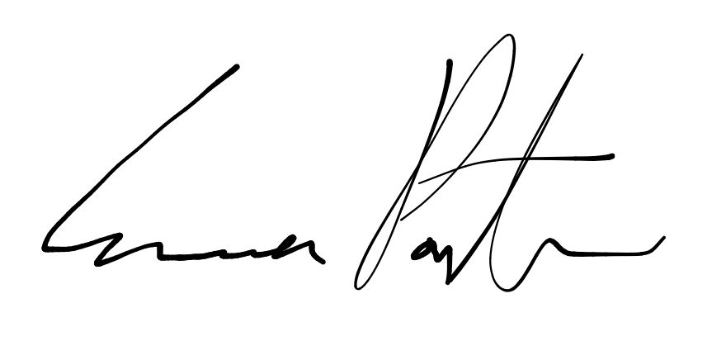

___________________________

**Emma Porter**

President

UBC Music Undergraduate Students’ Association

Respectfully submitted by

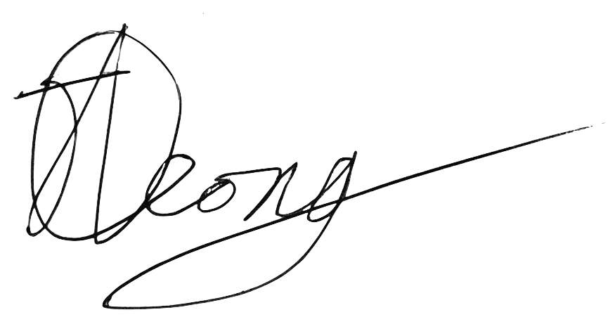

**Jobert Leong**

Vice President of Administration

UBC Music Undergraduate Students’ Association