**[ MUSA Council AGENDA ]**

Date: 10/02/24

Time: 8:00AM

Location: MUSA Office

1. **Attendance**

| **Name** | **Position** | **Attendance** |
| --- | --- | --- |
| Emma Porter | President |  |
| Sayako Leznoff | Interim VP Finance |  |
| Jobert Leong | VP Admin |  |
| Denise Chung | VP Internal |  |
|  | VP External |  |
|  | VP Student Resource |  |
|  | 4th Year Representative |  |
|  | 3rd Year Representative |  |
|  | 2nd Year Representative |  |
|  | 1st Year Representative |  |

1. **Call to Order**

The meeting was called to order at PDT

1. **Land Acknowledgement**

acknowledged that UBC’s Vancouver Point Grey campus is situated on the traditional, ancestral, unceded territory of the hən̓q̓əmin̓əm̓-speaking xʷməθkʷəy̓əm (Musqueam) people. The MUSA Council would also like to acknowledge that everyone is located in many places, near and far, and acknowledge the traditional owners and caretakers of those lands.

1. **Amendments to the Agenda**

1. **Adoption of the Agenda**

MOVED BY , SECONDED BY .

“BE IT RESOLVED THAT the agenda be adopted as ________.”

Result:

1. **Approval of Previous Meeting Minutes**

MOVED BY , SECONDED BY .

“BE IT RESOLVED THAT the meeting minutes of be adopted as _________.”

Result:

| **VII. Agenda Items** | **VIII. Action Items** |
| --- | --- |
| Elections | |
| * AGM * No candidates for 2nd year or 3rd year rep   + Are we okay not having a full council or should we move to elect members without running? |  |
| Retreat | |
| * Emma will send a poll in the insta chat with potential retreat options   + VSO, dinner, etc * What is our budget for retreat this year? |  |
| Inside Out 2 Movie Night | |
| * Who will be there? * Decorations * Food |  |
| EcoVillage Dog Therapy | |
| * In October or November, looking to bring in therapy dogs to the school of music for our first mental health event |  |
| Halloween Event | |
| * Brainstorm some different Halloween events to do in October   + Trick or treating, man hunt, pumpkin carving, etc |  |

1. **Adjournment**

“BE IT RESOLVED THAT there being no further business the meeting be adjourned at .”

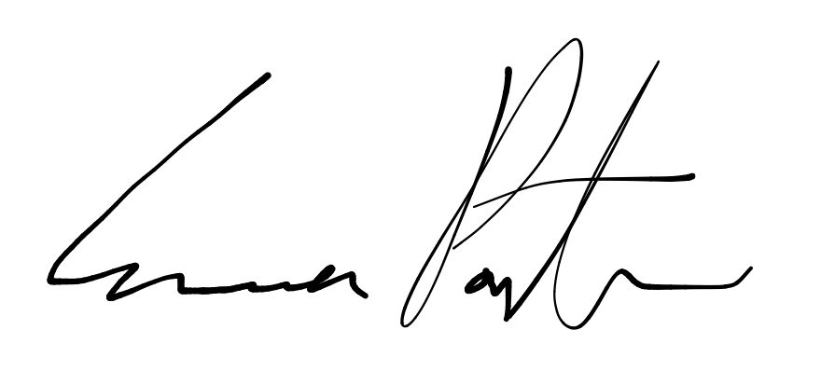

___________________________

**Emma Porter**

President

UBC Music Undergraduate Students’ Association

Respectfully submitted by

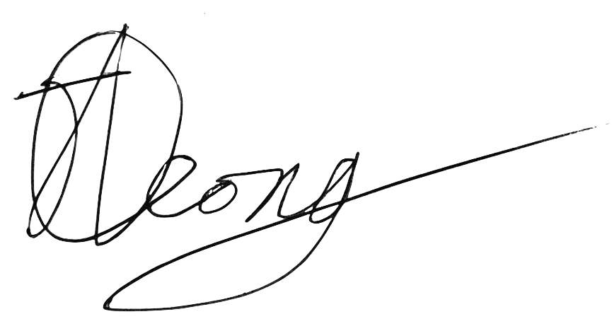

**Jobert Leong**

Vice President of Administration

UBC Music Undergraduate Students’ Association