**[ MUSA Council AGENDA ]**

Date: 11/04/24

Time: 8:00am

Location: MUSA Office

1. **Attendance**

| **Name** | **Position** | **Attendance** |
| --- | --- | --- |
| Emma Porter | President | P |
| Sayako Leznoff | VP Finance | P |
| Jobert Leong | VP Admin | P |
| Denise Chung | VP Internal | P |
| Deanicka Loy Sales | VP External | L |
| Mayvelee Bugh | VP Student Resource | P |
| Maryam Khamis | 4th Year Representative | A |
| Matthew Lew | 3rd Year Representative | L |
| Jalen Logan | 2nd Year Representative | P |
| Zaiden Grayda-Reyes | 1st Year Representative | L |

1. **Call to Order**

The meeting was called to order at 8:10am PDT

1. **Land Acknowledgement**

Emma acknowledged that UBC’s Vancouver Point Grey campus is situated on the traditional, ancestral, unceded territory of the hən̓q̓əmin̓əm̓-speaking xʷməθkʷəy̓əm (Musqueam) people. The MUSA Council would also like to acknowledge that everyone is located in many places, near and far, and acknowledge the traditional owners and caretakers of those lands.

1. **Amendments to the Agenda**

1. **Adoption of the Agenda**

MOVED BY JJ , SECONDED BY Mayvelee .

“BE IT RESOLVED THAT the agenda be adopted as presented_.”

Result:

1. **Approval of Previous Meeting Minutes**

MOVED BY , SECONDED BY .

“BE IT RESOLVED THAT the meeting minutes of be adopted as _________.”

Result:

| **VII. Agenda Items** | **VIII. Action Items** |
| --- | --- |
| Last week events - Recap | |
| * Pumpkin carving, halloween, fbf, bunny therapy * Pupmkin carving   + Throw out the pumpkins today * Halloween   + Faculty trick-or-treat     - Profs seemed very happy with the event     - A lot of profs weren’t around     - Maybe put out the notice sooner to give students time   + Door decorations     - We need to take down the decorations today * Rabbitats   + Big success! Maybe do it again?   + Noticed non-music majors attending and participating   + Spring bunny yoga |  |
| Colouring Event | |
| * November 21st, 12pm-3pm, Room 462 * Folder in the drive to upload blank colouring sheets * Post to go up on insta tomorrow * Saya will buy pencil crayons and snacks |  |
| Social Media | |
| * There has been a lot more interest in social media this year * Come up with a plan and role for people who want to participate in social media   + Create a tiktok? Post reels more frequently? Instagram story take over?     - Zaiden, Nov 20th, insta take over |  |
| Free Breakfast Friday | |
| * Thoughts? |  |

**IX. Adjournment**

“BE IT RESOLVED THAT there being no further business the meeting be adjourned at .”

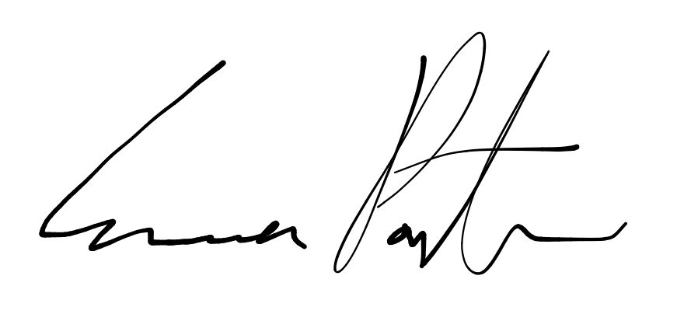

___________________________

**Emma Porter**

President

UBC Music Undergraduate Students’ Association

Respectfully submitted by

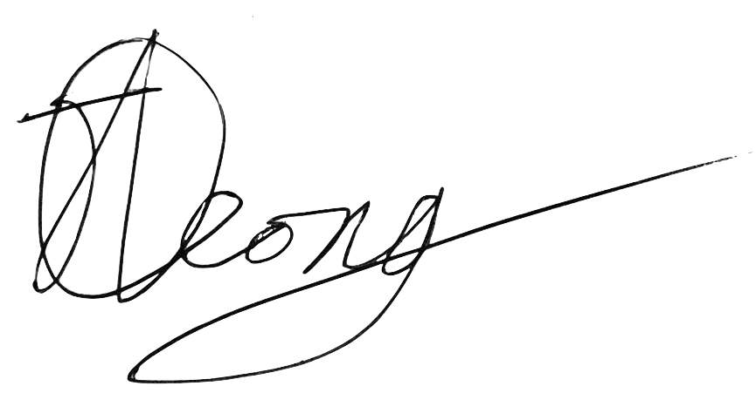

**Jobert Leong**

Vice President of Administration

UBC Music Undergraduate Students’ Association