**[ MUSA Council AGENDA ]**

Date: 09/04/24

Time: 8:00am

Location: MUSA Office

1. **Attendance**

| **Name** | **Position** | **Attendance** |
| --- | --- | --- |
| Emma Porter | President |  |
| Sayako Leznoff | Interim VP Finance |  |
| Jobert Leong | VP Admin |  |
| Denise Chung | VP Internal |  |
|  | VP External |  |
|  | AMS Representative |  |
|  | 4th Year Representative |  |
|  | 3rd Year Representative |  |
|  | 2nd Year Representative |  |
|  | 1st Year Representative |  |
|  | 4th Floor Lounge Manager |  |

1. **Call to Order**

The meeting was called to order at PDT

1. **Land Acknowledgement**

acknowledged that UBC’s Vancouver Point Grey campus is situated on the traditional, ancestral, unceded territory of the hən̓q̓əmin̓əm̓-speaking xʷməθkʷəy̓əm (Musqueam) people. The MUSA Council would also like to acknowledge that everyone is located in many places, near and far, and acknowledge the traditional owners and caretakers of those lands.

1. **Amendments to the Agenda**

1. **Adoption of the Agenda**

MOVED BY , SECONDED BY .

“BE IT RESOLVED THAT the agenda be adopted as ________.”

Result:

1. **Approval of Previous Meeting Minutes**

MOVED BY , SECONDED BY .

“BE IT RESOLVED THAT the meeting minutes of be adopted as _________.”

Result:

1. **Agenda Items**

* Imagine Day
  + Recap, thoughts, notes
* Locker Boothing
  + Overview of how it works
  + Schedule of boothing
* FBF
  + Schedule
  + Plan
* Elections
  + Dates for the upcoming election
  + Positions
    - VP External, VP Finance, AMS Rep, 1st Year Rep, 2nd Year Rep, 3rd Year Rep, 4th Year Rep, 4th Floor Lounge Manager (appointed)
      * Potential to remove AMS Rep in election and replace with VP Student Life or other

1. **Action Items**

1. **Adjournment**

“BE IT RESOLVED THAT there being no further business the meeting be adjourned at .”

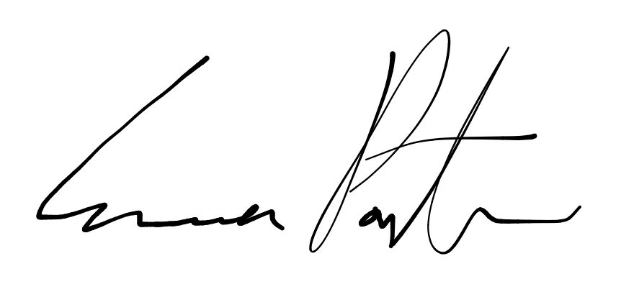

___________________________

**Emma Porter**

President

UBC Music Undergraduate Students’ Association

Respectfully submitted by

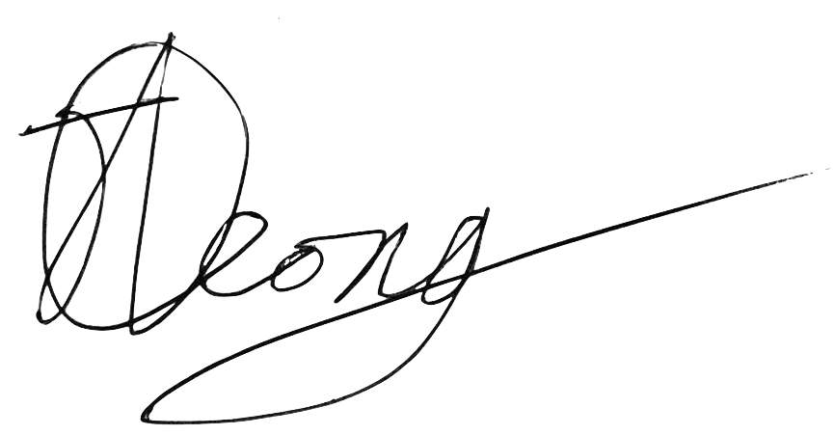

**Jobert Leong**

Vice President of Administration

UBC Music Undergraduate Students’ Association