**[ MUSA Council AGENDA ]**

Date: 03/11/25

Time: 7:15pm PST

Location: School of Music, Room 475

1. **Attendance**

| **Name** | **Position** | **Attendance** |
| --- | --- | --- |
| Emma Porter | President |  |
| Sayako Leznoff | VP Finance |  |
| Jobert Leong | VP Admin |  |
| Denise Chung | VP Internal |  |
| Deanicka Loy Sales | VP External |  |
| Mayvelee Bugh | VP Student Resource |  |
| Maryam Khamis | 4th Year Representative |  |
| Matthew Lew | 3rd Year Representative |  |
| Jalen Logan | 2nd Year Representative |  |
| Zaiden Grayda-Reyes | 1st Year Representative |  |

1. **Call to Order**

The meeting was called to order at ______ PDT

1. **Land Acknowledgement**

acknowledged that UBC’s Vancouver Point Grey campus is situated on the traditional, ancestral, unceded territory of the hən̓q̓əmin̓əm̓-speaking xʷməθkʷəy̓əm (Musqueam) people. The MUSA Council would also like to acknowledge that everyone is located in many places, near and far, and acknowledge the traditional owners and caretakers of those lands.

1. **Amendments to the Agenda**

1. **Adoption of the Agenda**

MOVED BY , SECONDED BY .

“BE IT RESOLVED THAT the agenda be adopted as .”

Result:

1. **Approval of Previous Meeting Minutes**

MOVED BY , SECONDED BY .

“BE IT RESOLVED THAT the meeting minutes of be adopted as _________.”

Result:

| **VII. Agenda Items** | **VIII. Action Items** |
| --- | --- |
| Election Candidates | |
| * Zarifa, Solomon, Kareen, Gagan, Jasper |  |
| Formal Boothing | |
| * Making the table more interactive and approachable |  |
| Formal Decoration Making | |
| * Wednesday, March 12th, 6:00pm, MUSA Office * Attendance? * Jar centerpieces, origami butterflies, moss mirror, trophies |  |
| MHE - Enchanted Crafts | |
| * Thursday, March 13th, 12pm-3pm, Room 304 * Attendance? * Do we have supplies?   + If not, shopping list   + Who can pick up? |  |
| Formal | |
| * Friday, March 14th, 6:30pm, Cecil Green * 5:00pm decoration pick-up from Office and drive to Cecil   + Denise and Matty * 5:30pm meet at Cecil to do set up   + Emma, Denise, Deanicka, JJ, Maryam, Saya, Mayvelee     - Put out table center pieces, string up vines around poles and banister, put out lanterns, put selfie mirror in cocktail room, set up polaroid frame outside (Emma), set up vine light wall, hang origami butterflies, etc. * Still to be picked up   + Jelly beans and jar * Formal superlatives   + Please vote and send to all your friends! Only takes 30 seconds   + Do we still believe musa members shouldn’t win? A couple people are in the running for things   + Who will announce each award? * Door prizes   + How many are secured?     - Beatty       * 1     - Loafe       * 2     - Chan       * 1     - Koerners       * 2     - Music office   + Who will draw for the prizes?     - Will use the yellow roll of tickets from the office * Photo Booth   + Confirm print design   + Has the deposit been paid? * Anything else we’re missing? |  |
| Music Jeopardy | |
| * Thursday, March 20th, 7:30pm, TBD * Attendance? * Have we heard back on our booking for MKF?   + If not, Deanicka go to AMS offices and ask John   + If we cannot use a room in the Nest, we will look into booking 462 |  |

**IX. Adjournment**

“BE IT RESOLVED THAT there being no further business the meeting be adjourned at .”

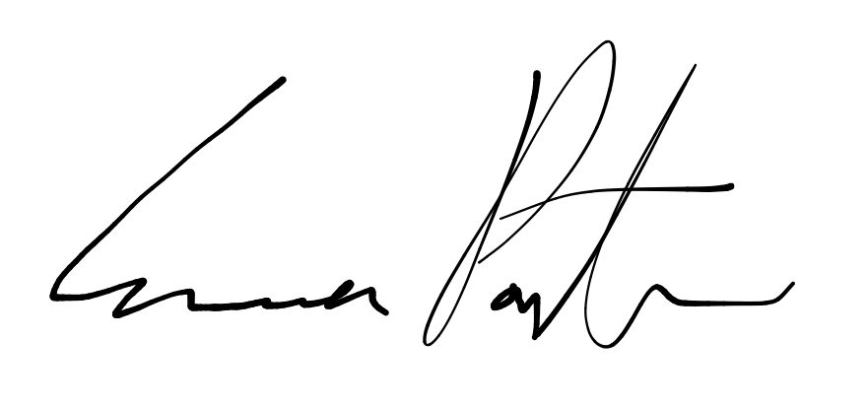

___________________________

**Emma Porter**

President

UBC Music Undergraduate Students’ Association

Respectfully submitted by

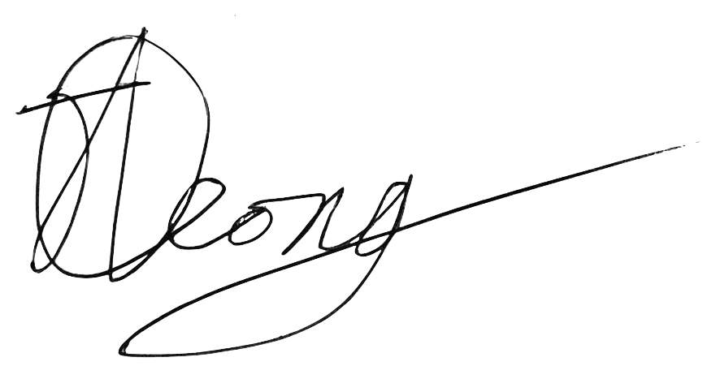

**Jobert Leong**

Vice President of Administration

UBC Music Undergraduate Students’ Association