**[ MUSA Council AGENDA ]**

Date: 03/17/25

Time: 7:00pm PST

Location: MUSA Office

1. **Attendance**

| **Name** | **Position** | **Attendance** |
| --- | --- | --- |
| Emma Porter | President | P |
| Sayako Leznoff | VP Finance | P |
| Jobert Leong | VP Admin | P |
| Denise Chung | VP Internal | P |
| Deanicka Loy Sales | VP External | P |
| Mayvelee Bugh | VP Student Resource | E |
| Maryam Khamis | 4th Year Representative | P |
| Matthew Lew | 3rd Year Representative | P |
| Jalen Logan | 2nd Year Representative | E |
| Zaiden Grayda-Reyes | 1st Year Representative | P |

1. **Call to Order**

The meeting was called to order at 7:06pm PDT

1. **Land Acknowledgement**

Emma acknowledged that UBC’s Vancouver Point Grey campus is situated on the traditional, ancestral, unceded territory of the hən̓q̓əmin̓əm̓-speaking xʷməθkʷəy̓əm (Musqueam) people. The MUSA Council would also like to acknowledge that everyone is located in many places, near and far, and acknowledge the traditional owners and caretakers of those lands.

1. **Amendments to the Agenda**

**Jobert**: Puzzle frames

**Denise**: Jars

1. **Adoption of the Agenda**

MOVED BY Jobert, SECONDED BY Denise.

“BE IT RESOLVED THAT the agenda be adopted as amended.”

Result: amended

1. **Approval of Previous Meeting Minutes**

MOVED BY Maryam, SECONDED BY Deanicka.

“BE IT RESOLVED THAT the meeting minutes of 03/11/25 be adopted as presented.”

Result: presented

| **VII. Agenda Items** | **VIII. Action Items** |
| --- | --- |
| Formal Recap | |
| * Photo gallery will be emailed to students once we receive the digital gallery from Vancity Photo Booth * **Denise** will get her jars back once the office is unlocked * Put clay figures in lounge * Any feedback received from other students?   + **Deanicka**: Food was good this year, positive word of mouth, people liked the Polaroid wall   + **Denise**: people really appreciated the mirror, people expected board/card games in the quiet room   + **Maryam**: people liked that we did it at Cecil Green again |  |
| AMS Awards Gala | |
| * Tuesday, March 18th, 5:30pm doors open, Convention Centre * Who is attending?   + Execs * Do we want to go together or separately?   + **Jobert** will transit there   + **Denise**, **Emma**, **Deanicka**, **Saya**, **Mayvelee** will carpool |  |
| Election | |
| * Candidates   + President: Sayako Leznoff, Jobert Leong   + VP Admin: Rue Beer   + VP Internal: Zaiden Grayda-Reyes   + VP External: Deanicka Loy Sales   + VP Student Resource: Mayvelee Bugh   + VP Finance: Lucy Moon * AGM   + Thursday, March 20th, 2-3pm, Room 338   + **Zaiden** will order pizza, **Deanicka** will pick up   + If any candidates cannot make it, they may submit a video   + Attendance?     - **Denise**, **Zaiden**, **Jobert**, **Maryam**, **Saya**, **Emma**, **Mayvelee** TBD | * **Denise**, **Zaiden**, **Jobert**, **Maryam**, **Saya**, **Emma**, **Mayvelee** TBD will be there |
| Music Jeopardy | |
| * Thursday, March 20th, 7:30pm, Room TBD * Attendance?   + **Maryam**, **Emma**, **Deanicka**, **Zaiden**, **Jobert**, **Denise**, **JJ**, **Mayvelee** * Emma is almost done writing the questions * Please reshare insta post and make sure to invite all your friends!!   + Teams of 4, musa member can and should participate * Pizza and snacks?   + Who will pick up?   + **Denise** will pick up snacks   + **Jobert** will pick up the AMS Food giftcards at the Nest on Thursday |  |
| Lounge puzzles | |
| * Purchase frames   + Measure dimensions for frame |  |

**IX. Adjournment**

“BE IT RESOLVED THAT there being no further business the meeting be adjourned at 7:34pm.”

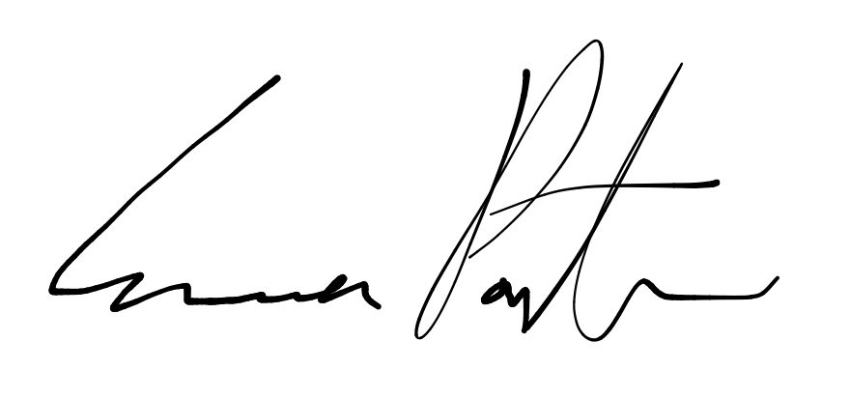

___________________________

**Emma Porter**

President

UBC Music Undergraduate Students’ Association

Respectfully submitted by

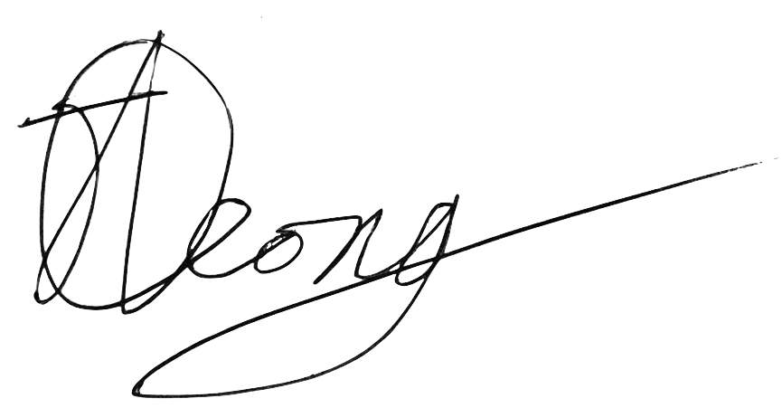

**Jobert Leong**

Vice President of Administration

UBC Music Undergraduate Students’ Association