**[ MUSA Council AGENDA ]**

Date: 01/09/25

Time: 2pm

Location: MUSA Office

1. **Attendance**

| **Name** | **Position** | **Attendance** |
| --- | --- | --- |
| Emma Porter | President | P |
| Sayako Leznoff | VP Finance | P |
| Jobert Leong | VP Admin | P |
| Denise Chung | VP Internal | E |
| Deanicka Loy Sales | VP External | P |
| Mayvelee Bugh | VP Student Resource | P |
| Maryam Khamis | 4th Year Representative | P |
| Matthew Lew | 3rd Year Representative | P |
| Jalen Logan | 2nd Year Representative | P |
| Zaiden Grayda-Reyes | 1st Year Representative | P |

1. **Call to Order**

The meeting was called to order at 2:09 PDT

1. **Land Acknowledgement**

Emma acknowledged that UBC’s Vancouver Point Grey campus is situated on the traditional, ancestral, unceded territory of the hən̓q̓əmin̓əm̓-speaking xʷməθkʷəy̓əm (Musqueam) people. The MUSA Council would also like to acknowledge that everyone is located in many places, near and far, and acknowledge the traditional owners and caretakers of those lands.

1. **Amendments to the Agenda**

1. **Adoption of the Agenda**

MOVED BY Mayvelee, SECONDED BY JJ.

“BE IT RESOLVED THAT the agenda be adopted as presented.”

Result: presented

1. **Approval of Previous Meeting Minutes**

MOVED BY Maryam, SECONDED BY Mayvelee.

“BE IT RESOLVED THAT the meeting minutes of 11/26/24 be adopted as approved.”

Result: approved

| **VII. Agenda Items** | **VIII. Action Items** |
| --- | --- |
| FBF | |
| * Friday, January 10th, 9am-12pm * 2 take away coffee carafes, 4 dozen donuts   + Tim Hortons   + Will need to be pre-ordered and picked up at 8:30am * Inventory Check   + Stir sticks, cups, lids, tea, tablecloth, napkins, extension cord, water heater, hot chocolate     - Option to buy takeaway hot chocolate & french vanilla from Tims as well * Sign-up for table times   + When2meet sent in slack   + https://www.when2meet.com/?28166566-evE6e   + 8:30am - 2 people pick up order from Tims   - 1 person set up table in the lobby  - 9am-10am  - 10am-11am  - 11am-12pm | * **Saya** and **Mayvelee** will pick up Tims breakfast at 8:30 * **Jobert** will setup table at 8:30 * 9-10: Jobert, Saya, Mayvelee * 10-11: Mayvelee (til 10:30), Deanicka, Zaiden * 11-12: Jobert, Saya |
| Retreat | |
| * Pushed our retreat dinner into the new year * When2meet sent in slack   + https://www.when2meet.com/?28166540-ANKRz * If we choose just the one retreat instead of two (usually one per semester), can the budget possibly be increased?   + **Saya**: Can spend more (additional $150 from cancelled bowling event) | * Fill out when2meet: <https://www.when2meet.com/?28166540-ANKRz> |
| Social Media | |
| * Maryam’s turn for instagram takeover! * Any reels people want to make? * Takeover:   + Next week: **Saya** (Jan 13-17)   + Order after that: **Deanicka** (Jan 20-24), **Mayvelee** (Jan 27-31), **Jobert** (Feb 5), **Denise** (Feb 10-14), **Emma** (February 28th) | * Takeover: * Next week: **Saya** (Jan 13-17) * Order after that: **Deanicka** (Jan 20-24), **Mayvelee** (Jan 27-31), **Jobert** (Feb 5), **Denise** (Feb 10-14), **Emma** (February 28th) |
| Candy Grams | |
| * Origami hearts, candy bags   + $2 heart, $3 candy bag * Boothing the 2 weeks leading up to Valentine’s Day (Feb 3-7, 10-13) 9am-2pm   + When2meet sent in slack   + <https://www.when2meet.com/?28166692-64Yub> | * Fill out when2meet: <https://www.when2meet.com/?28166692-64Yub> |
| Merch | |
| * Waiting on the link for UBC School of Music hoodies to drop from the bookstore |  |
| Formal | |
| * Venue   + Great Hall North has been booked for February 28th from 4pm-12am     - Hopefully change to March 14th (Friday), since people were complaining   + Everyone who is able, will meet at the hall for 4pm to set up food and decorations and get ready for the event * Food   + Food platters and snacks from the grocery store will be picked up day of * Alcohol   + To ensure we can have alcohol but underage students can still attend, we will need to hire a bartender     - AMS bartender or do we want to find an outside source? * Decorations   + <https://pin.it/4LV02pvBL>   + We should create a decoration committee of 4-5 people to help decide what to use and what we can make vs need to buy     - Committee will present ideas at meeting on Jan 23rd * Photo Booth   + Do we hire the same company as last year or just hire a roaming photographer and no booth? * Tickets   + $15 early bird (1st week of boothing), $20 regular (2nd-3rd week of boothing), $25 at the door   + Selling Ticket options     - Lobby boothing the 3 weeks leading up to the event       * There’s a middle week of reading break so we won't be able to booth the whole time     - Bounce App       * An event app used by the AMS and other constituencies to sell tickets for events, have upload photo and comments option       * Tickets do have a small fee (either students pay $10 and we receive $8.41 of that, or they pay $11.59 and we receive $10)       * Benefit is that we don't have to booth and students would have a downloadable ticket * Music   + Hire a DJ again |  |
| Mental Health Event | |
| * Lunar New Year   + Red banner calligraphy (January 23rd, 12-3pm) - **Jobert**, **JJ**, **Maryam**     - **Mayvelee** will book room (475?)   + **Jobert** will buy red banner paper, red packets, and chocolate coins (latter two for Lunar New Year Event) | * Red banner calligraphy (January 23rd, 12-3pm) - **Jobert**, **JJ**, **Maryam**   + **Mayvelee** will book room (475?) * **Jobert** will buy red banner paper, red packets, and chocolate coins (latter two for Lunar New Year event on the 29th) |
| Lounge Decoration | |
| * Decorations from christmas need to be taken back to the office * Making sure we are putting our posters up in the lounge for all our events |  |
| Pub Night | |
| * Koerner’s, the Gallery, the Pit   + We will have to make this explicitly a 19+ event to ensure no one gets in trouble   + NUS joint event? |  |

**IX. Adjournment**

“BE IT RESOLVED THAT there being no further business the meeting be adjourned at 3:03.”

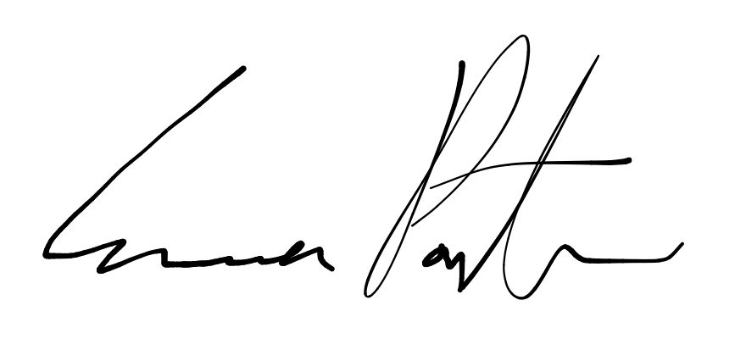

___________________________

**Emma Porter**

President

UBC Music Undergraduate Students’ Association

Respectfully submitted by

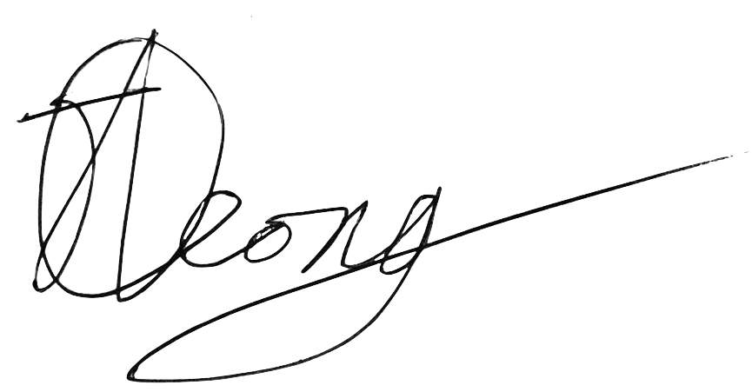

**Jobert Leong**

Vice President of Administration

UBC Music Undergraduate Students’ Association