**[ MUSA Council AGENDA ]**

Date: 11/26/24

Time: 8:00am

Location: MUSA Office

1. **Attendance**

| **Name** | **Position** | **Attendance** |
| --- | --- | --- |
| Emma Porter | President | P |
| Sayako Leznoff | VP Finance | P |
| Jobert Leong | VP Admin | P |
| Denise Chung | VP Internal | L |
| Deanicka Loy Sales | VP External | P |
| Mayvelee Bugh | VP Student Resource | L |
| Maryam Khamis | 4th Year Representative | P |
| Matthew Lew | 3rd Year Representative | L |
| Jalen Logan | 2nd Year Representative | P |
| Zaiden Grayda-Reyes | 1st Year Representative | P |

1. **Call to Order**

The meeting was called to order at 8:10am PDT

1. **Land Acknowledgement**

Emma acknowledged that UBC’s Vancouver Point Grey campus is situated on the traditional, ancestral, unceded territory of the hən̓q̓əmin̓əm̓-speaking xʷməθkʷəy̓əm (Musqueam) people. The MUSA Council would also like to acknowledge that everyone is located in many places, near and far, and acknowledge the traditional owners and caretakers of those lands.

1. **Amendments to the Agenda**

1. **Adoption of the Agenda**

MOVED BY JJ , SECONDED BY Denise .

“BE IT RESOLVED THAT the agenda be adopted as .”

Result:

1. **Approval of Previous Meeting Minutes**

MOVED BY Saya , SECONDED BY JJ .

“BE IT RESOLVED THAT the meeting minutes of be adopted as _________.”

Result:

| **VII. Agenda Items** | **VIII. Action Items** |
| --- | --- |
| Colouring Event | |
| * Recap   + Need pencil sharpeners next time   + 462 maybe too big * Putting up the colouring photos in the lounge?   + On the bookshelf in the lounge |  |
| First Year Interfaculty Event | |
| * Musa can contribute resources instead of money |  |
| Retreat | |
| * We will be waiting until the new year |  |
| Social Media | |
| * JJ instagram takeover this week!   + Thursday, 12pm   + Maryam, JJ, Denise, Mayvelee * Reels that need to be filmed this week   + Santa kidnap |  |
| Merch | |
| * Thank you to the half of the team that took the time to fill out my form on what merch you want * The winner seems to be “UBC MUSA” |  |
| Formal | |
| * Theme: Enchanted Forest * Venue   + Requests have been sent to Alumni Center   + Cannot submit booking request to the Nest until Jan 2, 2025   + Are there any other venues people may want to use? * Food   + Do we want the event to have full dinner catering or just snacks?     - Food platters * Decorations   + <https://pin.it/4LV02pvBL>     - This is a pinterest vision board, please add! * Tickets   + $10 early bird, $15 regular, $20 at the door |  |
| Holiday Party | |
| * Tuesday, December 3rd, 7pm, 4th Floor Lounge   + Who will be there?     - Emma, Mayvelee, Denise, Zaiden, Jobert, JJ, Deanicka, Maryam, Matty * Denise, Saya, and Jobert heading to Costco before the event * Supplies needed:   + Gingerbread houses, hot chocolate, Baileys, cups and stir sticks,spoons, kettle, construction paper, scissors, glue, decorations, tree, lights * Emma will bake cookies for the event * Please make sure to share post on social media   + Need to print a poster to go up in the 4th floor lounge     - Zaiden will print |  |

**IX. Adjournment**

“BE IT RESOLVED THAT there being no further business the meeting be adjourned at 8:56am .”

**

___________________________

**Emma Porter**

President

UBC Music Undergraduate Students’ Association

Respectfully submitted by

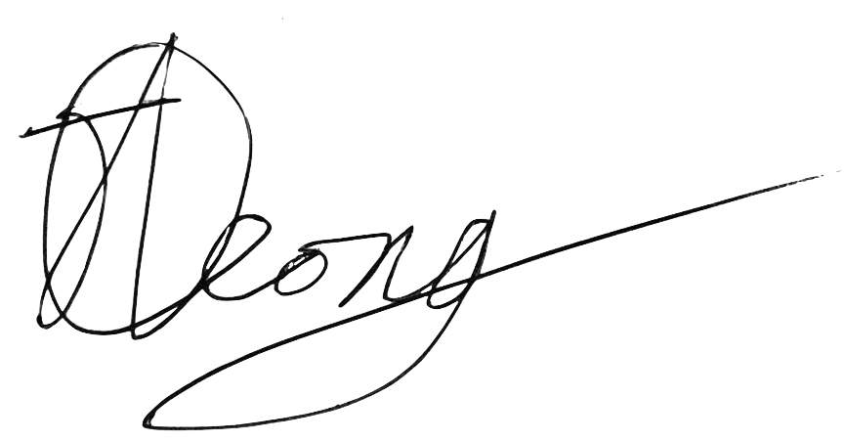

**Jobert Leong**

Vice President of Administration

UBC Music Undergraduate Students’ Association