**[ MUSA Council AGENDA ]**

Date: 10/16/24

Time: 8:00AM

Location: MUSA Office

1. **Attendance**

| **Name** | **Position** | **Attendance** |
| --- | --- | --- |
| Emma Porter | President |  |
| Sayako Leznoff | Interim VP Finance |  |
| Jobert Leong | VP Admin |  |
| Denise Chung | VP Internal |  |
|  | VP External |  |
|  | VP Student Resource |  |
|  | 4th Year Representative |  |
| Matthew Lew | 3rd Year Representative |  |
| JJ Logan | 2nd Year Representative |  |
|  | 1st Year Representative |  |

1. **Call to Order**

The meeting was called to order at PDT

1. **Land Acknowledgement**

acknowledged that UBC’s Vancouver Point Grey campus is situated on the traditional, ancestral, unceded territory of the hən̓q̓əmin̓əm̓-speaking xʷməθkʷəy̓əm (Musqueam) people. The MUSA Council would also like to acknowledge that everyone is located in many places, near and far, and acknowledge the traditional owners and caretakers of those lands.

1. **Amendments to the Agenda**

1. **Adoption of the Agenda**

MOVED BY , SECONDED BY .

“BE IT RESOLVED THAT the agenda be adopted as ________.”

Result:

1. **Approval of Previous Meeting Minutes**

MOVED BY , SECONDED BY .

“BE IT RESOLVED THAT the meeting minutes of be adopted as _________.”

Result:

| **VII. Agenda Items** | **VIII. Action Items** |
| --- | --- |
| Elections | |
| * Delay in election   + Voting is happening this week, encourage students to vote * 2nd and 3rd Year Rep   + Welcome to Matty and JJ!! |  |
| Inside Out 2 Movie Night | |
| * Happening tomorrow!   + Please make sure to invite all your friends * Emma will go to the store today and pick up all the supplies   + Balloons, popcorn kernels, butter, halloween candy   + How much pizza are we ordering and who wants to pick it up? * Room Booking   + AMS is super backed up on bookings and never replied     - AMS has replied and given us Room 2506 from 8pm-11pm     - This is not within the time frame we asked for, may be late for the event to start   + Should we move it to 462? Other room options?     - I have booked 462 from 6pm-10pm as a precaution |  |
| Pumpkin Carving |  |
| * Post for the pumpkin carving to go out this week * Purchase the carving tools   + Order online or have Emma find a set when she buys everything for the movie night |  |
| Rabbitats |  |
| * Emma has reached out to Rabbitats for potential “meet & treat” event * Price is a $250 donation |  |
| Mental Health Event |  |
| * Should plan a mental health event in November to go with rabbitats/in case rabbitats falls through |  |
| Gallery Night |  |
| * To give some time away from Koerner’s but still host a social, the Gallery could be a good option * Dates in November?   + Nov 4th or 5th at 7pm |  |
| Other events in 1st Term |  |
| * Are there any other events we want to do in this term? * “Charity” Concert   + Do we want to wait until 2nd term or are people still wanting to do it this semester? |  |

1. **Adjournment**

“BE IT RESOLVED THAT there being no further business the meeting be adjourned at .”

**

___________________________

**Emma Porter**

President

UBC Music Undergraduate Students’ Association

Respectfully submitted by

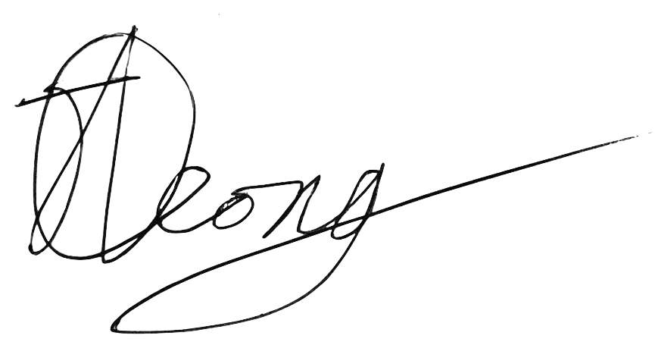

**Jobert Leong**

Vice President of Administration

UBC Music Undergraduate Students’ Association