**[ MUSA Council AGENDA ]**

Date: 09/11/24

Time: 8:00am

Location: MUSA Office

1. **Attendance**

| **Name** | **Position** | **Attendance** |
| --- | --- | --- |
| Emma Porter | President |  |
| Sayako Leznoff | Interim VP Finance |  |
| Jobert Leong | VP Admin |  |
| Denise Chung | VP Internal |  |
|  | VP External |  |
|  | AMS Representative |  |
|  | 4th Year Representative |  |
|  | 3rd Year Representative |  |
|  | 2nd Year Representative |  |
|  | 1st Year Representative |  |
|  | 4th Floor Lounge Manager |  |

1. **Call to Order**

The meeting was called to order at PDT

1. **Land Acknowledgement**

acknowledged that UBC’s Vancouver Point Grey campus is situated on the traditional, ancestral, unceded territory of the hən̓q̓əmin̓əm̓-speaking xʷməθkʷəy̓əm (Musqueam) people. The MUSA Council would also like to acknowledge that everyone is located in many places, near and far, and acknowledge the traditional owners and caretakers of those lands.

1. **Amendments to the Agenda**

1. **Adoption of the Agenda**

MOVED BY , SECONDED BY .

“BE IT RESOLVED THAT the agenda be adopted as ________.”

Result:

1. **Approval of Previous Meeting Minutes**

MOVED BY , SECONDED BY .

“BE IT RESOLVED THAT the meeting minutes of be adopted as _________.”

Result:

1. **Agenda Items**

* MUSA logo - copyright rules
  + Jobert has looked into the rules surrounding copyright with our logo
* Hot water station
  + Jobert would like to speak about the option for a hot water station
* Lockers
  + How has the boothing been going? How is the spreadsheet?
  + Problems with any lockers:
* Koerner’s Night
  + Should have our first one within September 23rd-September 27th
    - Can use this as an opportunity for students running in the election to get their signatures
* Elections
  + Have we found a new elections coordinator?
  + Vote on removing the AMS Rep and create the VP Student Resource position
  + Find a date to schedule AGM in the week of September 23rd-27th
* Truth and Reconciliation Day
  + Emma reached out to musicians in mid-August about performing at the tuning fork and received no response
  + Potential of MUSA going to the march and inviting students to join us instead

1. **Action Items**

1. **Adjournment**

“BE IT RESOLVED THAT there being no further business the meeting be adjourned at .”

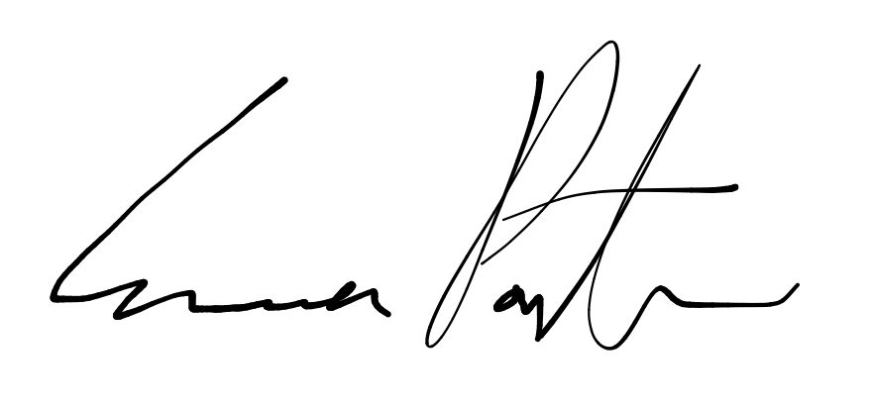

___________________________

**Emma Porter**

President

UBC Music Undergraduate Students’ Association

Respectfully submitted by

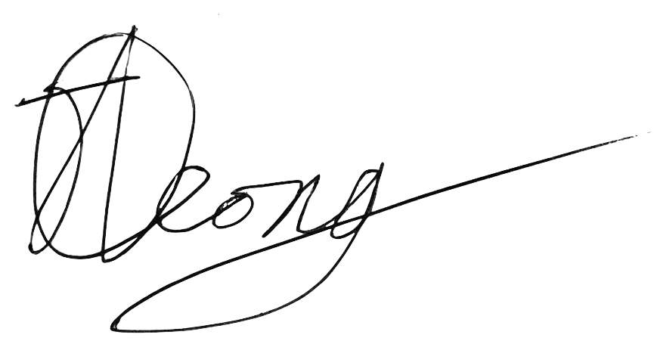

**Jobert Leong**

Vice President of Administration

UBC Music Undergraduate Students’ Association